

**INFORMATICS INSTITUTE OF TECHNOLOGY**

**In collaboration, with**

**UNIVERSITY OF WESTMINSTER (UoW)**

BSc/ BSc (Hons) in Computer Science

Final Year Project 2017/18

Project Initial Document

For

**User Experience Enhancement in SCRUM**

**Using Gamification**

By

2014081

Vishwa Kanahcna Perera

Supervised by

Mr. Pumudu Fernando

_____________________ ___________________

Signature of Supervisor Signature of Student

# Background

SCRUM is a Framework which was built to practice Agile Methodology and currently it is named to be quite successful in the industry. SCRUM only focus on the delivery of the product / project. In order to enhance the productivity outcome of SCRUM there should be a method we can use to motivate the developers.

By using Gamification elements/mechanism it is said that it was possible to improve engagement of users. This study is about how gamification elements/mechanizes improve the productive of the SCRUM.

# Aim

* To produce a New Framework enhancing SCRUM, where it’s possible to enhance out comes of a sprint.
* To apply gamification on SCRUM framework to increase the productivity among SCRUM team.
* To producing a positive motivation with in the team.
* To Increase the positive experience in using SCRUM

# Objectives

## Research Objectives

* Gather information on different gamification mechanism;

in order to produce the best user experience first task would be analyzing all the gamification mechanisms which have we development up till now and to choose which is best suitable for the SCRUM framework

* Analyze the SCRUM framework in depth;

To apply gamification machines in the SCRUM framework, knowing all the sensitive part in the framework is a must, and to avoid damages to the SCRUM framework by any means

* Analyze current software which is practicing SCRUM framework

There are several software’s which practices SCRUM framework (JIRA, Bitrix24). Which include set of basic features which represent the core features of the SCRUM. Analyzing which is necessary and which is additions is a must before producing a new system.

* Analyzing gamification mechanism in depth

It is said that not every gamification mechanism will fit in with everything, need to do a survey to find out which mechanism will be the most appropriating to enhance the experience SCRUM for the developer

* Analyze existing systems with the gamification

In order to achieve the expected user experience, it’s always a plus point to analyze the pros and cons in the existing system, which may or may not include gamification aspect

* System comparison after the adaptation of the gamification

Checking the improvements and deteriorations of the system after the adaptations of the selected gamification mechanisms

## Common Objectives

# Scope

Develop a system which enhance the productivity of developers who are using SCRUM Methodology. Deliverable would be the Browser plugin and a web application which include a SCRUM management system. Browser extension is to allow user to have quick access/ quick view of the progress of himself to access the system in a high level. Web application is the full system which will hold base of the system, Project Management Application.

Scope does not include a fully developed project management application, and only quotients which are required to explain the gamification mechanisms will be developed.

**Definition of Problem**

Even though the SCRUM methodology plays vital role in improving the delivery rate of a piece of software which has uncertain and undefined requirements. The methodology is not optimized accordingly to get the maximum productivity.

# Literature Review

## Introduction

Waterfall methodology and Agile Methodology has involved with software development for a long time. simple Waterfall method is being used for certain and defined requirement based projects while Agile method was used for project with uncertain requirements. Both methods are mature and has its own advantages and disadvantages. But in the modern society Agile method has become quite useful as most software doesn’t not tend have fixed requirements.

As a matter of fact, “*Agile works best when members of the development team are completely dedicated to the project*” [Lotz M, 2013]. In such occasions, there is a high possibility that, working on the same project for a long time tend to get bored. For such occasions, there is nothing much we could do about it unless we have altered the software developments methodology in a way that it motivated developers to contently engage with work.

SCRUM is a Framework which was built to practice Agile Methodology and currently it is named to be quite successful in the industry. Also SCRUM itself is a gamified system but not quite gamified enough in the aspect of making user motivate in order to proceed with day to day tasks.

## SCRUM Methodology

**During last couple of years, Agile Software Development methodology has become a trending topic alongside with SCRUM framework, which is not just due to its gentle learning curve but also because of its effectiveness against all the pieces of software which are non-predictable because of its uncertain requirements changes.

Figure : Search hit for "Agile Software Development and SCRUM"

*“The SCRUM approach treats these systems development processes as a controlled black box.”* (Schwaber K, 1994), SCRUM was introduced as a methodology which can manage, enhance and maintain an existing system or a newly developed production prototype. When we move further deep we can identify that each iteration also known as a sprint constant of all of the standard Waterfall phases, but each sprint only addresses few selected functionalities of the set phase.

But as a matter of fact, “*Agile works best when members of the development team are completely dedicated to the project*” (Lotz M, 2013). In such occasions, there is a high possibility that, working on the same project for a long time tend to get bored. For such occasions, there is nothing much we could do about it unless we have altered the software developments methodology in a way that it motivated developers to consistently engage with work.

## Gamification

On the other hand, Gamification has been a trending topic and “*a subject to hype as a means of supporting user engagement and enhancing positive patterns in service use”*( Hamari, et al., 2014) Which is beneficial in order to increase user activity, social interaction, or in quality and productivity of actions.

In 2014 Juho Hamari and Jonna Koivisto from University of Tampere Along with Harri Sarsa from Aalto University, did a study related to “Studied motivational affordances and psychological/behavioral outcomes” proving that different services/activates expect different types of Motivational Categories and different types of Motivational Affordance. Which them lead us to the next aspect, which is, Combining both SCRUM and Gamification Mechanisms effectively. Table 1 show an abstract of “Studied motivational affordances and psychological/behavioral outcomes”

|  |  |  |  |
| --- | --- | --- | --- |
| Core Service/Activity | Motivational Affordance | Behavioral Outcome | Psychological Outcomes |
| Q&A websites | Badges | Behavior changed due to receiving badges |  |
| Virtual human patient for training healthcare students | Leaderboard, Narrative (story, theme), Deadline (challenge) | Number and duration of interactions with virtual patient likelihood of voluntary participation to a virtual patient interaction | Difference in user’s approach to virtual patient interactions |
| Online idea Competition | Points, Leaderboard |  | Motivation, degree of happiness, flow, enjoyment, task involvement |
| Computer-mediated idea generation environment | Goals, Feedback | Performance (in idea generation) |  |

Table 1: Studied motivational affordances and psychological/behavioral outcomes abstracted from “Does Gamification Work? — A Literature Review of Empirical Studies on Gamification”

## Analyzing Motivational Affordance

When we take a look at the Software product release plan, most of the time it is planned based on these features;

* Requirements: What are the changes need to enhance the current system
* Time duration: Delivery times, to gain competitive advantage
* Market competition: What are the current standards and what is required to best them
* Quality: What is the expected quality by the market
* Task breakdown according to the vision: What type of changes need to undergo to full fill the initial vision of the system
* Human resources and other resources: Managing the resources according to its availability

By taking all these variables into account, we realized that motivation is a must fact for the developers to succeed during sprint. By combining Scrum with Gamification mechanism, we can alter the target. From Finishing the product to the deadline to finish it fast as possible. ‘table 2’ shows how activities in SCRUM methodology shows a similarity with the Core Services which was shown in the ‘table 1’. Though all these activities do not align perfectly coincide, end mechanism shows a quite a big similarity.

|  |  |  |  |  |
| --- | --- | --- | --- | --- |
| (in Comparison with) SCRUM | Core Service/Activity | Motivational Affordance | Behavioral Outcome | Psychological Outcomes |
| Bugs and Solutions (Quality) | Q&A websites | Badges | Behavior changed due to receiving badges |  |
| Number of Tasks Completed during a minimum amount of time (Time Duration) | Virtual human patient for training healthcare students | Leaderboard, Narrative (story, theme), Deadline (challenge) | Number and duration of interactions with virtual patient likelihood of voluntary participation to a virtual patient interaction | Difference in user’s approach to virtual patient interactions |
| Recreated bug solving process (Human Resources and other resources) | Online idea Competition | Points, Leaderboard |  | Motivation, degree of happiness, flow, enjoyment, task involvement |
| Initial Sprint Planning/ 15 minutes Standup meetings (Requirement Gathering) | Computer-mediated idea generation environment | Goals, Feedback | Performance (in idea generation) |  |

*Table 2: Studied motivational affordances and psychological/behavioral outcomes abstract in comparison with SCRUM methodology*

## Combining SCRUM with Gamification Mechanisms

With the comparison, it is clear that not every Gamification mechanisms will be accountable in Scrum Methodology if we take into comparison with “Studied motivational affordances and psychological/behavioral outcomes*”*. Badges, Leaderboard (point system), Deadlines, Feedbacks and goals are the most suitable with SCRUM methodology. To the date there are 3 noticeable type of gamification approaches (Chou Y K, 2013),

1. Collectable Driven Aka **Achievement Symbols**
2. Character Driven Aka **Status Points**
3. Player Driven Aka **Leader Board**

There are incidents where we can see Collectable Driven Mechanism is the best fit as it’s has multiple opportunities which leads to different aspects, for an example, Swarm, which includes a Collectable Driven mechanism and all the stickers falls into different groups. And some of them doesn’t quite make sense. For a System like SCRUM, having just Collectable Driven System, would make the system either trash or limited. With the extension of gamification mechanism, applying Character driven mechanism to represent the developer himself. With a leveling mechanism which he/she gains levels according to SCRUM activates would be much more convenient, also might represent a more playful environment.

Yet again, having just Character Driven system would not be enough as Character Driven Mechanic shows its own cons, Restricting the system just for a Character Driven will lead the developers just to see his/her own progress, will not give any driving force to outperform others.

This is when the importance of a hybrid system occurs as none of above gamification approaches would fit in solemnly own their own.

## Sorting Gamification Elements

|  |  |  |
| --- | --- | --- |
| Affordance | Required / Not Required | Reasoning |
| Points | Not Required | Weight of a particular task varies from person to person |
| Leader Board | Required | Drives an individual to push further to perform better |
| Achievements / Badges | Not Required | Could use a surprise element but not necessarily |
| Levels | Required | Show case the progress |
| Story / Theme | Not Required | It’s not feasible to apply a story |
| Clear Goals | Required | Each sprint has clear goals |
| Feed Back | Required | Each stand up meeting required feed backs |
| Rewards | Not Required | Could use a surprise element but not necessarily |
| Progress | Required | In order to display ones progress |
| Challenge | *Surprise element | Could use a surprise element but not necessarily |

## Conclusion

SCRUM is a methodology which has a dedicated team of developers, assigned to finish a particular project, which does not have defined requirements and uncertain features, there for the team is supposed to undergo rapid delivery of the product in complete functionalities. Most of the time this process be tiring for developers as they have to keep on working on the same project for some duration. In order to enhance the productivity and to motivate developers creating gamified environments

In this process choosing it’s advised to choose the correct gamification elements to enhance experience towards positivity. In order to get the required outcome, surveys on each and every feature should be done individually as individual component as each component hold its own value for the system individually.

# List of Requirements

Web browser (Chrome Preferred)

Average Computer (i3 Processor)

**Time Schedule**

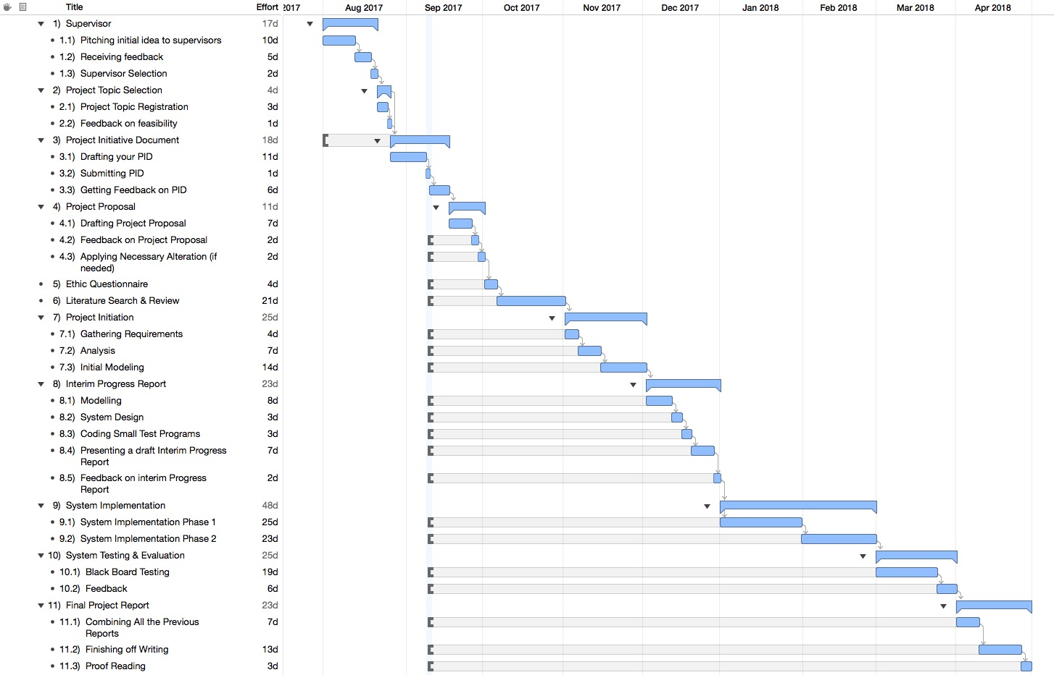

# Bibliography

1. Mora, A., Riera, D., Gonzalez, C. and Arnedo-Moreno, J., 2015, September. A literature review of gamification design frameworks. In *Games and virtual worlds for serious applications (VS-Games), 2015 7th international conference on* (pp. 1-8). IEEE.
2. da Rocha Seixas, L., Gomes, A.S. and de Melo Filho, I.J., 2016. Effectiveness of gamification in the engagement of students. *Computers in Human Behavior*, *58*, pp.48-63.
3. Hsu, C.L., Chen, Y.C., Yang, T.N. and Lin, W.K., 2017. Do website features matter in an online gamification context? Focusing on the mediating roles of user experience and attitude. *Telematics and Informatics*, *34*(4), pp.196-205.
4. Dubois, D.J. and Tamburrelli, G., 2013, August. Understanding gamification mechanisms for software development. In *Proceedings of the 2013 9th Joint Meeting on Foundations of Software Engineering* (pp. 659-662). ACM.
5. Lombriser, P. and van der Valk, R., 2011. Improving the Quality of the Software Development Lifecycle with Gamification.
6. Buckley, P. and Doyle, E., 2017. Individualising gamification: an investigation of the impact of learning styles and personality traits on the efficacy of gamification using a prediction market. *Computers & Education*, *106*, pp.43-55.
7. Robson, K., Plangger, K., Kietzmann, J.H., McCarthy, I. and Pitt, L., 2015. Is it all a game? Understanding the principles of gamification. *Business Horizons*, *58*(4), pp.411-420.

# Citations

1. Lotz, M. 2013. Waterfall vs. Agile: Which is the Right Development Methodology for Your Project?. [ONLINE] Available at: https://www.seguetech.com/waterfall-vs-agile-methodology/. [Accessed 8 September 2017].
2. Chou, Y.K. 2013. The 8 Core Drives of Gamification (#2): Development and Accomplishment. [ONLINE] Available at: http://yukaichou.com/gamification-study/8-core-drives-gamification-2-development-accomplishment/. [Accessed 10 September 2017].
3. Schwaber, K., 1994. SCRUM Development Process. Advanced Development Methods, 1, 23.
4. Hamari, J, Koivisto . J, Sarsa. H, (2014). Does Gamification Work? — A Literature Review of Empirical Studies on Gamification. In International Conference on System Science. Hawaii, 2014. Hawaii: IEEE. pp3025 - 3034.

